Name: Maryam Rashid

Class: BSCS-7A

Reg no. 215511

**Task 1 and 2:**

var http = require('http');

http.createServer(function (req, res) {

res.writeHead(200, {'Content-Type': 'text/plain'});

res.end('Hello World\n');

}).listen(1337, "127.0.0.1");

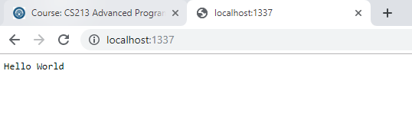

**Task 3 and 4:**

var http = require('http');

var dt = require('./myfirstmodule');

http.createServer(function (req, res) {

res.writeHead(200, {'Content-Type': 'text/plain'});

res.write("The date and time are currently: " + dt.myDateTime());

res.end();

}).listen(1337, "127.0.0.1");

exports.myDateTime = function () {

  return Date();

}

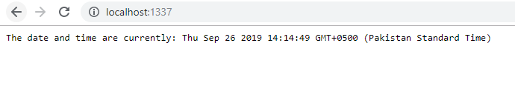

**Task 5 and 6:**

var http = require('http');

http.createServer(function (req, res) {

res.writeHead(200, {'Content-Type': 'text/plain'});

res.end('Hello World\n');

}).listen(1337, "127.0.0.1");

**Task 7:**

var http = require('http');

var fs = require('fs');

http.createServer(function (req, res) {

  fs.readFile('file.txt', function(err, data) {

   res.writeHead(200, {'Content-Type': 'text/html'});

   res.write(data);

   res.end(); });

}).listen(8080);

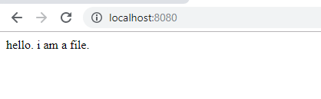

**Task 8:**

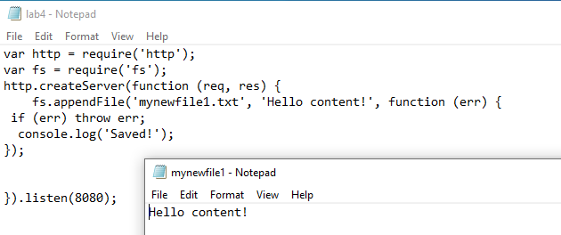

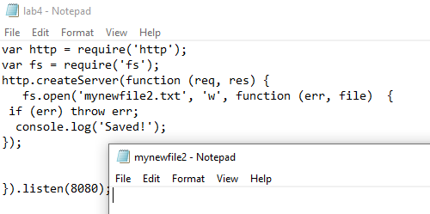

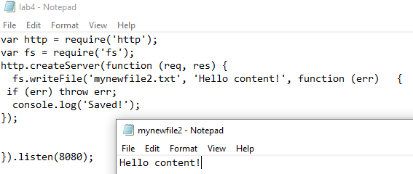

**Task 9:**

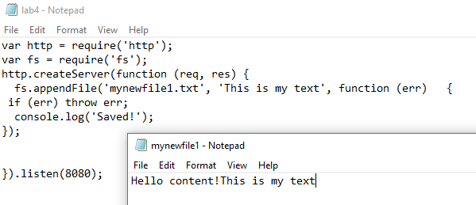

**Task 10:**

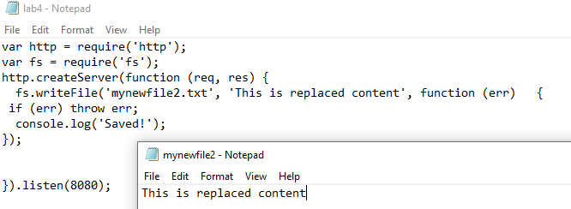

**Task 11:**

var http = require('http');

var fs = require('fs');

http.createServer(function (req, res) {

fs.unlink('mynewfile2.txt', function (err) {

 if (err) throw err;

  console.log('Deleted!');

});

}).listen(8080);

**Task 12:**

